PRELUDE (let us quiet our hearts before the Lord)
Welcome to BUMC! Our church family is delighted that you have joined us to worship today! We pray that you will be blessed by our worship service. We invite those who are not members to consider membership. Please speak with the Pastor or Lay Leader.

CENTERING HYMN “Come Sinners to the Gospel Feast” (verse 1) UMH 616

CALL TO WORSHIP:
L: Followers of Christ, God calls us just as we are to live as truth-tellers and gospel-bringers in the world.
P: God, we know you call us, and still, we ask, “Who am I that you would call me?”
L: Like Moses standing before the burning bush convinced of his unworthiness to lead your people out of bondage, we ask.
P: “Who am I that you would call me?”
L: Like Peter who thought he got it right only to realize that who Jesus is doesn’t meet his expectations of who a Savior should be, we ask,
P: “Who am I that you would call me?”
L: As we raise this question to God today, we open our hearts to receive God’s answer:
ALL: You are my beloved children. You are my disciples. You are my people called to share the love of God for the transformation of the world. Amen.
OPENING HYMN “God of Grace and God of Glory” UMH 577

PASTORAL PRAYER

OPENING PRAYER: Lord of summer sunshine and autumn harvest, be with us this day as we gather to encounter your word and your way for us. Remind us that we can place our trust in your eternal love. Enable us to be more effective in our witness to that love by word and deed. Guide our steps and pick us up when we falter. Dust us off and place us on the pathways of grace and service. These things we pray in Jesus’ name. Amen.
WELCOME AND GREETINGS

PSALTER Psalm 105 UMH 828

1st READING Exodus 3: 1-15
L: This is the Word of God
P: For the People of God

JOYS, SHARINGS, CONCERNS & PRAYERS OF THE PEOPLE

PRAYER OF CONFESSION: God of love and mercy, be with us this day. We have faltered in our service to you. We create divisions between various people; we judge before we listen; we condemn before we make any attempt to understand. Our lives are in turmoil, and we confess that we have turned away from you. It is fear and anger that too often surrounds us, and our actions become based on those fears and anger. Slow us down, Lord. Give us hearts overflowing with grace and compassion. Help us to mirror Jesus who loved and healed others who were rejected by “polite” society. Remind us that we are called to be strong voices of hope for those who feel alienated and lost; we are called to be a home to strangers; to quench thirst and to give nourishment; to welcome and bring words of hope. Forgive us when we have forgotten these things. In Jesus’ Name, we pray. Amen.

MUSIC MINISTRY BUMC Choir

GOSPEL READING Matthew 16: 21-28
L: This is the Gospel of the Lord
P: Praise to You Lord Jesus Christ

SERMONIC SONG “Holy Ground” TFWS 2272

SERMON Pastor Egan Bovell

HOLY COMMUNION
PRAYER OF DISCIPLESHIP

TITHES AND OFFERINGS

DOXOLOGY

NOTICES & ANNOUNCEMENTS

CLOSING HYMN “Here I am Lord” UMH 593

BENEDICTION

*************************************************************************
Our Mission Statement

The Bloomfield United Methodist Church’s mission is to be an instrument of God’s purpose in the world by coming together as a Christian faith community which is open to all ages and races; promoting spiritual growth and Christian ideals in daily living; providing opportunity for worship; nurturing and caring for one another; educating our children so they will know God; and reaching out to, and welcoming in the community and the world.

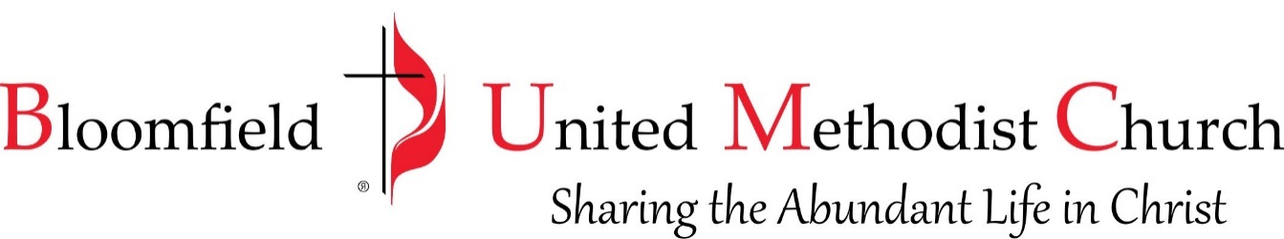

14th Sunday after Pentecost
September 3, 2023
11:00am
