PRELUDE (let us quiet our hearts before the Lord)
Welcome to BUMC! Our church family is delighted that you have joined us to worship today! We pray that you will be blessed by our worship service. We invite those who are not members to consider membership. Please speak with the Pastor or Lay Leader.

CALL TO WORSHIP:
L: To you, O Lord, we lift up our souls.
P: Complete our joy as we praise you today.
L: Make us know your ways, O Lord; teach us your paths.
P: Complete our joy as we empower students and young leaders to follow you.
L: Lead us in your truth, and teach us, for you are the God of our salvation.
P: Complete our joy as we gather around the table of truth and taste and see your salvation.
L: Do not remember the sins of our youth or our transgressions; according to your steadfast love remember us.
All: Complete our joy for your goodness’ sake, O Lord. To you, O Lord, we lift up our souls and invite you to complete our joy. Amen.

OPENING HYMN “Jesus Shall Reign” UMH 157

OPENING PRAYER: God of hope and peace, you are with us in all our days and in all our ways. As you walked with the Israelites in the desert, when they had given up hope, you came to them with nourishment and your steadfast love. As Jesus walked through Jerusalem, healing the sick and those afflicted, your love was made abundantly clear through acts of love and mercy. Be with us this day as we gather to hear your word. Inspire and encourage us in all that we do, that we may serve you faithfully, bringing hope and your message of love to your thirsting world. In Jesus’ name, we pray. Amen.

WELCOME & GREETINGS

PSALTER Psalm 78 UMH 799

1st READING Exodus 17: 1-7
L: This is the Word of God
P: For the People of God

SHARINGS, JOYS, CONCERNS & PRAYERS OF THE PEOPLE
MUSIC MINISTRY BUMC Choir

GOSPEL READING John 6: 24-35
L: This is the Gospel of the Lord
P: Praise to You Lord Jesus Christ

SERMONIC HYMN “Break Thou the Bread of Life” UMH 599

SERMON Pastor Egan Bovell

PRAYER OF DISCIPLESHIP

HOLY COMMUNION

TITHES AND OFFERING

DOXOLOGY

NOTICES & ANNOUNCEMENTS

CLOSING HYMN “Victory in Jesus“ UMH 370

BENEDICTION

Our Mission Statement

The Bloomfield United Methodist Church’s mission is to be an instrument of God’s purpose in the world by coming together as a Christian faith community which is open to all ages and races; promoting spiritual growth and Christian ideals in daily living; providing opportunity for worship; nurturing and caring for one another; educating our children so they will know God; and reaching out to, and welcoming in the community and the world.

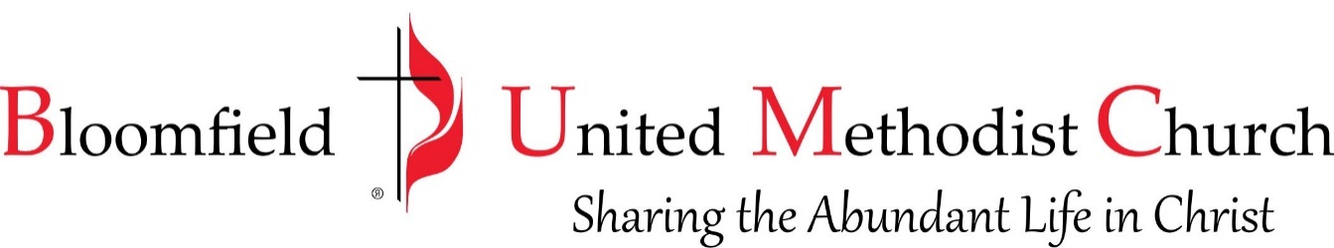

18th Sunday after Pentecost
October 1, 2023
11:00am
