CALL TO WORSHIP
L: On this All-Saints Day, we gather to join the multitude of saints across the generations from all tribes, peoples, and languages, to proclaim.
P: Salvation belongs to our God, who is seated on the throne, and to the Lamb!
L: We come to remember, to grieve, and to celebrate those saints who have come before, yet whose lives and witness continues to teach us.
P: Salvation belongs to our God, who is seated on the throne, and to the Lamb!
L: We gather today as the family of Christ, siblings, and saints, diverse yet united by grace to live lives that declare.
P: Salvation belongs to our God, who is seated on the throne, and to the Lamb!
L: May we be guided today by the lamb who is our Shepherd, the one who gathers us, comforts us and tends us.
ALL: May we join in the work of the Shepherd to bring about a world with no more hunger, no more thirst, no more suffering, and no more pain that all the saints of the past, the present, and future may share in God’s abundant life. Amen.

OPENING HYMN “For All the Saints” UMH 711

PASTORAL PRAYER

OPENING PRAYER: Loving and generous God, we come to you hungry and thirsty for your word. Satisfy our hunger, quench our thirst, nourish our soul. Teach us to listen and heed your promises and receive the abundance of your inexhaustible grace. We pause to remember the faithfulness of your servants from all generations, from all peoples, in all languages, who shared in word and deed the many wonders of your love and grace. And now, with hope in our hearts, we again respond to your call to carry the God News of Jesus Christ, in all languages, beginning here in our communities., across all borders and to the ends of the earth. Send us in the power of your Holy Spirit to join your mission of bearing witness to your So, our Lord, who in a humble Nazarene synagogue announced: “Today this Scripture has been fulfilled in your hearing. Amen.

WELCOME & GREETINGS

PSALTER Psalm 34 UMH 769

1st READING Joshua 3: 7-17

CELEBRATIONS, CONCERNS & PRAYERS OF THE PEOPLE

2nd READING 1 John 3:1-3

MUSIC MINISTRY BUMC Choir

GOSPEL READING Matthew 5: 1-12

SERMONIC HYMN “Because He Lives” UMH 364

SERMON “A Charge to Keep Before We Sleep”
Pastor Egan Bovell

PRAYER OF DISCIPLESHIP

HOLY COMMUNION

LITANY OF REMEMBRANCE

TITHES AND OFFERING

OFFERTORY PRAYER

NOTICES & ANNOUNCEMENTS

CLOSING HYMN “Marching To Zion“ UMH 733

BENEDICTION
PRAYER LINE – Tuesdays at 6:30am
Phone #: 848 220 3300 / Conference ID #: 5203248

ZOOM BIBLE STUDY – Wednesdays at 7:00pm
Meeting ID: 873 3085 4771 / Passcode: 810341

LEADERS MEETING – Saturday, November 11, 2023, at 9:30am
All leaders, committee chairs and other interested persons are invited to come and lend your voice to the vision and future of our church.

North UMC has invited us to join them for a Festival of Hymns on Sunday, November 12 at 4:00 pm (1205 Albany Avenue, Hartford).

Any member or friend who is interested in learning more about mental health resources or how the faith community can become more aware, you are invited to take a flyer from the table in the lobby. Should you have any questions, feel free to speak to the Pastor.

PRAYER LIST: Billie & Michael Anthony, Liz Donar, Rev. Boliver Valentine, Audrey Nathan, Avril Wallace, Anthony and I-rose Gordon, Molly Williams, Leroy Clemons, Roy Greaves, Demery family, Robert Brown, Ted Baron, Boris, the families of Margaret Leslie, Derek Bruce and all those experiencing the loss of loved ones.
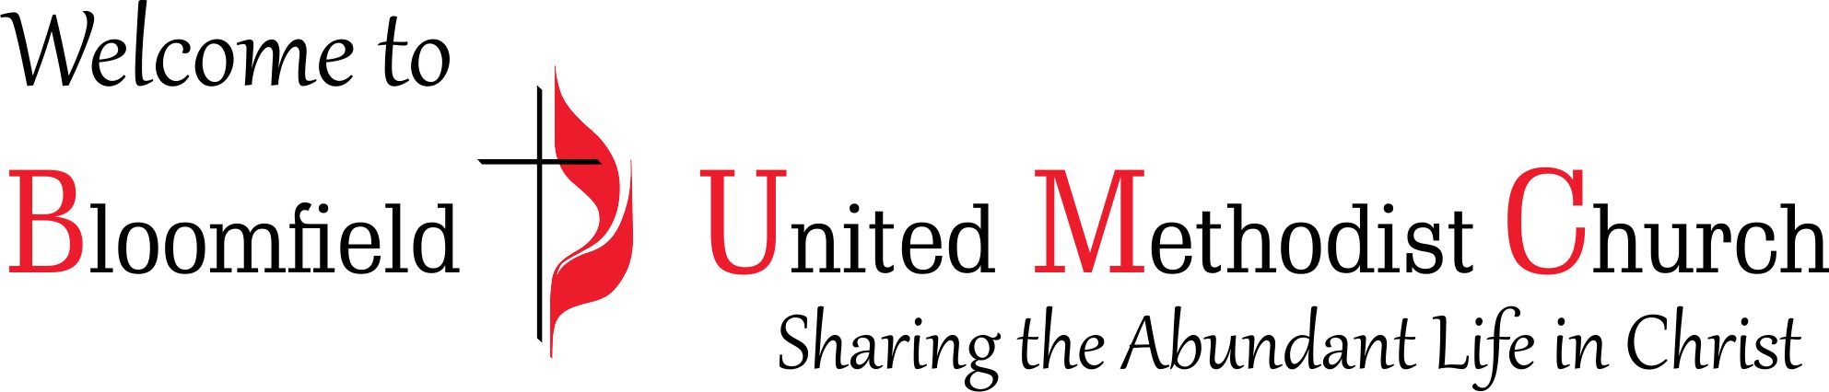

All Saints Sunday
23rd Sunday after Pentecost
November 5, 2023
11:00am

