INTROIT “He Has Made Me Glad” TFWS 2270

PROCESSIONAL

CALL TO WORSHIP
L: God’s great love is amazing.
P: Amazing love makes God great.
L: God’s great love is amazing. God loves us with a steadfast love.
P: Let the redeemed of the Lord say so!
L: God loves us so much he gave us his Son.
P: Let us believe and have eternal life!
L: God loves us with a great love, rich in mercy.
P: Let us have faith to receive this grace!
L: Give thanks to the Lord, for God is good. His great love is amazing.
ALL: God’s great love is amazing. Amen.

OPENING HYMN “My Hope is Built” UMH 368

PASTORAL PRAYER
OPENING PRAYER: Great Triune God, we have gathered here in your name as an act of faith, believing that you are not only among us, but that you love us. It is often hard to recognize your love, see your mercy, and feel your presence. Help us today in our worship, that we might be transparent to your grace, as you reveal yourself to each one of us. Amen.
WELCOME & GREETINGS
PSALTER Psalm 106: 1-12 sung response UMH 829
1st READING Ephesians 2: 1-10
SHARINGS, JOYS, CONCERNS & PRAYERS FOR THE WORLD
REAFFIRMATION OF FAITH, RECEPTION INTO THE UMC & RECEPTION INTO LOCAL CONGREGRATION
MUSIC MINISTRY BUMC Youth Bell Choir
GOSPEL READING John 3: 14-21
SERMONIC HYMN “Spirit of the Living God” UMH 394
SERMON Rev. Dr. Alpher Sylvester District Superintendent of the CT District UMC
PRAYER OF DISCIPLESHIP
MUSIC MINISTRY Sis. Gail Ellis
HOLY COMMUNION
TITHES AND OFFERINGS
DOXOLOGY UMH 95
NOTICES & ANNOUNCEMENTS
CLOSING HYMN “Because He Lives” UMH 364
BENEDICTION Rev. Dr. Alpher Sylvester
PRAYER LINE – Tuesdays at 6:30am
Phone #: 848 220 3300 / Conference ID #: 5203248

ZOOM BIBLE STUDY – Wednesdays at 7:00pm
Meeting ID: 873 3085 4771 / Passcode: 810341

UPCOMING SERVICES/ACTIVITIES:
Palm Sunday Service – March 24, 2024 at 11am
Good Friday Service – March 29, 2024 at 5pm
Children & Youth Easter Celebration – Saturday, March 30, 2024 at 4pm
Easter Sunday Service – March 31, 2024 at 11:00am

PRAYER LIST: Brenda Ifill, Cheryl Pringle, Ron Dixon, Carmen Edith Morris, Billie & Michael Anthony, Liz Donar, Rev. Boliver Valentine, Audrey Nathan, Avril Wallace, Anthony and I-rose Gordon, Molly Williams, Leroy Clemons, Roy Greaves, Demery family, Robert Brown, Ted Baron, Boris, the families of Margaret Leslie, Derek Bruce, Norma Murphy and all those experiencing the loss of loved ones.

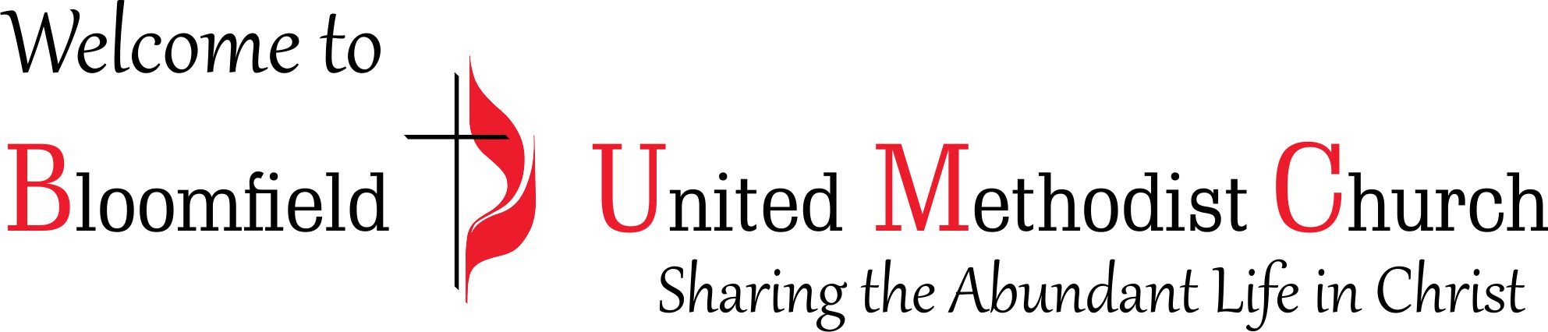

4th Sunday in Lent
Reaffirmation of Faith, Reception into the United Methodist Church & Reception into Local Congregation Sunday

March 10, 2024
11:00am

