CALL TO WORSHIP
L: In the beginning, God…
P: Swept over waters, spoke light into existence, created day and night and called it good.
L: As the days and nights of creation filled with life, God…
P: Made humanity out of the dirt to love and tend creation, to be loved and tended by God.
L: As we lost our way, God…
P: Sent Jesus, Love Incarnate, to show us the way back.
L: On the day Jesus came to the banks of the Jordan River to be baptized, God…
P: Declared, “You are my Son, the Beloved; with you I am well pleased.”
L: Let us, then ,follow Jesus into the waters, remembering our baptism in which God….
ALL: Claims us as beloved children, the family of God. Amen.

OPENING HYMN “Come Let Us Use the Grace Divine” UMH 606

PASTORAL PRAYER

OPENING PRAYER: Holy God, Eternal Spirit, we thank you for baptizing us into one body in Jesus the Christ. Wash over us with your Spirit, that, like Jesus, we may serve you in serving humanity. Baptize us with the fire of your truth, through Jesus Christ. Amen.

WELCOME AND GREETINGS

1ST READING Isaiah 40:21-31
PSALTER “Glory Be to the Father” UMH 71

SHARINGS, JOYS, CONCERNS & PRAYERS OF THE PEOPLE
TIME WITH THE CHILDREN

MUSIC MINISTRY

GOSPEL READING Mark 1: 29-39

SERMONIC SONG “Holy Spirit Rain Down” Video

SERMON Pastor Egan Bovell

COVENANT RENEWAL: Adoration, Thanksgiving & Confession

HYMN “Breathe on Me, Breath of God” UMH 420

THE COVENANT

HOLY COMMUNION

TITHES AND OFFERINGS

OFFERTORY PRAYER

NOTICES & ANNOUNCEMENTS

CLOSING HYMN “Spirit Song“ UMH 347

BENEDICTION
PRAYER LINE – Tuesdays at 6:30am
Phone #: 848 220 3300 / Conference ID #: 5203248

ZOOM BIBLE STUDY – Wednesdays at 7:00pm
Meeting ID: 873 3085 4771 / Passcode: 810341

PRAYER LIST: Ron Dixon, Carmen Edith Morris, Billie & Michael Anthony, Liz Donar, Rev. Boliver Valentine, Audrey Nathan, Avril Wallace, Anthony and I-rose Gordon, Molly Williams, Leroy Clemons, Roy Greaves, Demery family, Robert Brown, Ted Baron, Boris, the families of Margaret Leslie, Derek Bruce and all those experiencing the loss of loved ones.

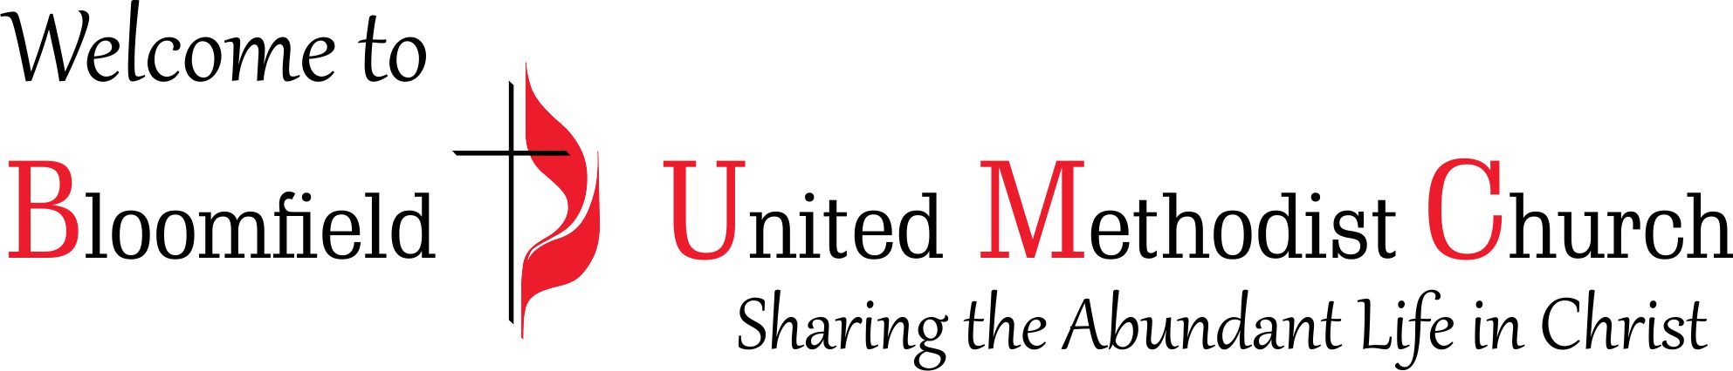

1st Sunday after the Epiphany
Baptism of the Lord
Covenant Renewal Sunday
January 7, 2024
11:00am

