CALL TO WORSHIP
L: Christ is calling you as disciples
P: Lord Jesus, let us follow you faithfully.
L: You will be led into fields of mission and service.
P: Lord Jesus, where you lead us, we will go.
L: Listen for Christ’s call to you.
P: We are ready to serve the Lord. Amen.

OPENING HYMN “Grace Greater Than Our Sin” UMH 365

PASTORAL PRAYER

OPENING PRAYER (in unison): O God, you are our light and our salvation. Living in your presence, we have nothing to fear. Open our hearts to your word this day. As we hear the story of the call of the first disciples, make us ready to follow Jesus on whatever path he leads us. Cast aside our fears and doubts, and teach us to trust wholly in you. For we ask this in Jesus’ Name. Amen.

WELCOME & GREETINGS

PSALTER Psalm 62 UMH 787

THE GLORIA PATRI UMH 71

PRAYER OF CONFESSION (in unison): We can get caught up in selfish pursuits and completely over- look the wonders of your creation, O God. All around us are majestic reminders of the beauty you offer to us. But we are weak and easily trapped into attitudes of indifference or destructive behavior. You have not given this world to us that we should destroy it, but rather that we should cherish it and make sure that all receive from its bounty. Forgive our overwhelming greed and selfishness. Help us to let go of the petty desires for wealth, position, and power, and bring us into a ministry which proclaims your love and justice for all your people. These things we pray in the name of the Master Servant, Jesus Christ, our Lord. Amen.

1st READING Jonah 3: 1-5,10
SHARINGS, JOYS, CONCERNS & PRAYERS OF THE PEOPLE

TIME WITH THE CHILDREN
2nd READING 1 Corinthians 7: 29-31

MUSIC MINISTRY Youth Bell Choir

GOSPEL READING Mark 1: 14-20

PRAISE & WORSHIP
“We Bring the Sacrifice of Praise” TFWS 2031
“I Have Decided To Follow Jesus” TFWS 2129
“Praise the Name of Jesus” TFWS 2066

SERMONIC HYMN “Turn Your Eyes Upon Jesus” UMH 349

SERMON “Fishing Isn’t the Same as Catching”
Pastor Egan Bovell

PRAYER OF DISCIPLESHIP

TITHES AND OFFERINGS

OFFERTORY PRAYER

NOTICES & ANNOUNCEMENTS

CLOSING HYMN “Where He Leads Me” UMH 338

BENEDICTION
PRAYER LINE – Tuesdays at 6:30am
Phone #: 848 220 3300 / Conference ID #: 5203248

ZOOM BIBLE STUDY – Wednesdays at 7:00pm
Meeting ID: 873 3085 4771 / Passcode: 810341

PRAYER LIST: Ron Dixon, Carmen Edith Morris, Billie & Michael Anthony, Liz Donar, Rev. Boliver Valentine, Audrey Nathan, Avril Wallace, Anthony and I-rose Gordon, Molly Williams, Leroy Clemons, Roy Greaves, Demery family, Robert Brown, Ted Baron, Boris, the families of Margaret Leslie, Derek Bruce and all those experiencing the loss of loved ones.

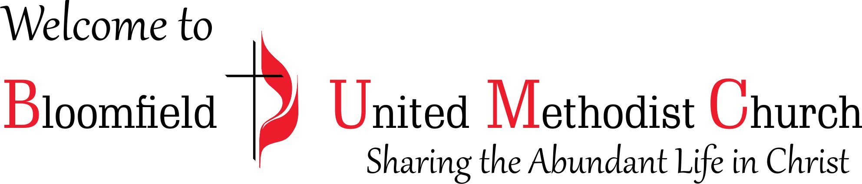

3rd Sunday after the Epiphany

January 21, 2024
11:00am

