CALL TO WORSHIP
L: Let us turn our minds from human things.
P: Our faith in Jesus saves us.
L: Let us set our minds on divine things.
P: Our faith in Jesus saves us.
L: We will deny ourselves and take up our cross.
P: Our faith in Jesus saves us.
L:We will lose all; that we may gain all.
All: Our faith in Jesus saves us. Amen.

OPENING HYMN “Lift Every Voice and Sing” UMH 519

PASTORAL PRAYER

OPENING PRAYER (in unison): God, you have given us everything. What can we give in return for our lives? Be our guide on our Lenten journey. Help us to deny ourselves, pick up our cross and follow Jesus. We welcome the chastening direction in our lives as we worship you today. Amen.

WELCOME & GREETINGS

PRAYER OF CONFESSION (in unison): Merciful God, we confess that our sin turns us from you again and again. We are a sinful generation longing for your mercy. We want not only to save our lives, but to gain the whole world as well. We are too often ashamed to show our faith to the world around us. Have mercy on us. Amen.

LITANY OF AFFIRMATION Insert

BLACK HISTORY MOMENT

1st READING Genesis 17: 1-7, 15-16

SHARINGS, JOYS, CONCERNS & PRAYERS OF THE PEOPLE

MUSICAL INTERLUDE

GOSPEL READING Mark 8: 31-38

PRAISE & WORSHIP
“O How I Love Jesus” UMH 170
“Guide My Feet” TFWS 2208
“Sanctuary” TFWS 2164

SERMON Pastor Egan Bovell

PRAYER OF DISCIPLESHIP

DOXOLOGY UMH 95

NOTICES AND ANNOUNCEMENTS

CLOSING HYMN “Take Up Thy Cross” UMH 415

BENEDICTION

PRAYER LINE – Tuesdays at 6:30am
Phone #: 848 220 3300 / Conference ID #: 5203248

ZOOM BIBLE STUDY – Wednesdays at 7:00pm
Meeting ID: 873 3085 4771 / Passcode: 810341

New Members Welcome Service – March 10, 2024

PRAYER LIST: Brenda Ifill, Cheryl Pringle, Ron Dixon, Carmen Edith Morris, Billie & Michael Anthony, Liz Donar, Rev. Boliver Valentine, Audrey Nathan, Avril Wallace, Anthony and I-rose Gordon, Molly Williams, Leroy Clemons, Roy Greaves, Demery family, Robert Brown, Ted Baron, Boris, the families of Margaret Leslie, Derek Bruce and all those experiencing the loss of loved ones.

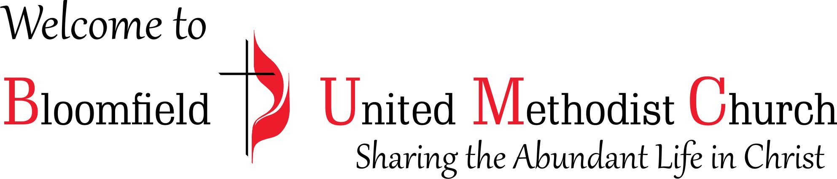

2nd Sunday in Lent
Black History Month

February 25, 2024
11:00am

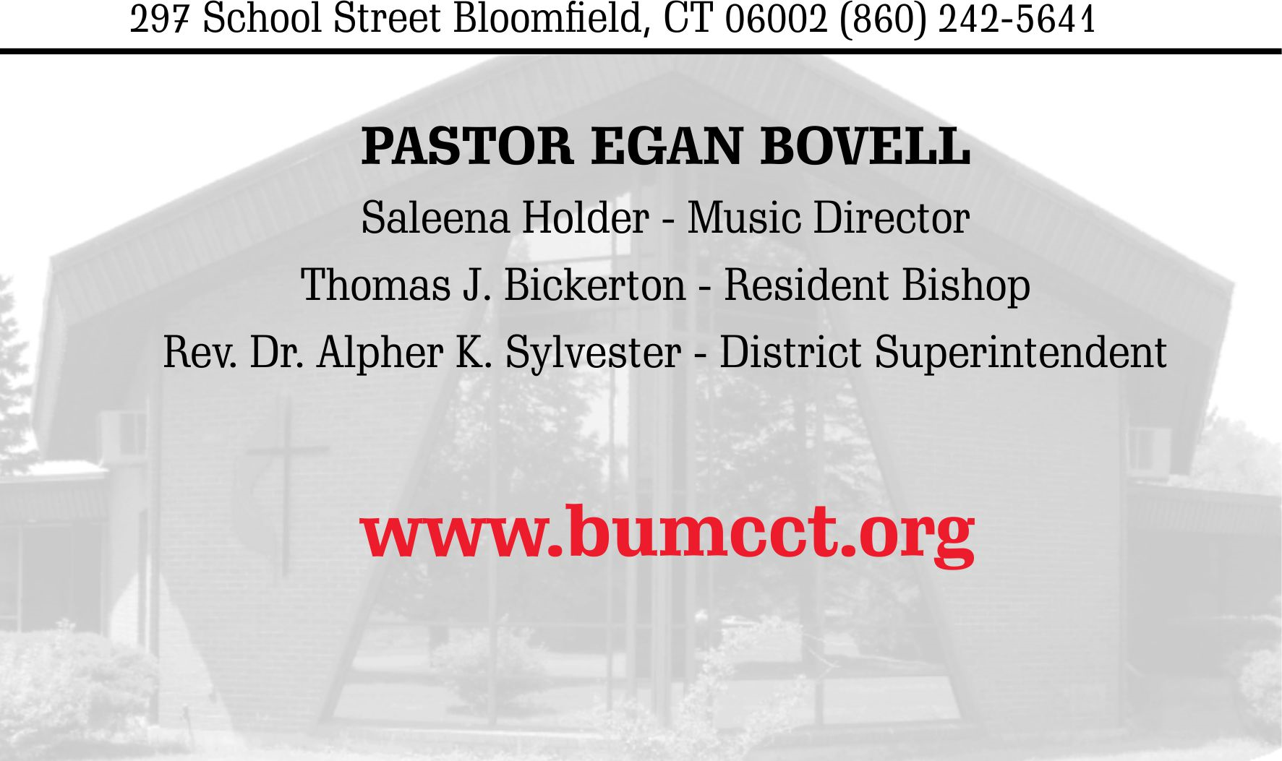

LITANY OF AFFIRMATION
(based on Psalm 124)

L: If the LORD had not been on our side
ALL: Let all the people say, if the LORD had not been on our side
L: If the LORD had not been on our side—let Israel say—
ALL: If the LORD had not been on our side when we were attacked, when anger flared like a flash fire against us.
L: If the LORD had not been on our side, our enemies would have swallowed us alive.
ALL: Our ancestors would have all perished in the Middle Passage.
L: Our ancestors would have all died in slavery in the Americas.
ALL: If the LORD had not been on our side—let all the people say if the Lord had not been on our side, the flood would have engulfed us.
L: If the LORD had not been with us, the torrent would have swept us into the seas; the raging waters would have swept us away.
ALL: Praise the LORD who has not let us be torn by their teeth.
L: Praise the LORD, we have escaped like a bird out of the fowler’s snare.
ALL: Praise the LORD, the snare has been broken, and we have escaped.
One: Our help is in the name of the LORD, the maker of heaven and earth.
ALL: God is our help, the maker of heaven and earth. Amen.

LITANY OF AFFIRMATION
(based on Psalm 124)

L: If the LORD had not been on our side
ALL: Let all the people say, if the LORD had not been on our side
L: If the LORD had not been on our side—let Israel say—
ALL: If the LORD had not been on our side when we were attacked, when anger flared like a flash fire against us.
L: If the LORD had not been on our side, our enemies would have swallowed us alive.
ALL: Our ancestors would have all perished in the Middle Passage.
L: Our ancestors would have all died in slavery in the Americas.
ALL: If the LORD had not been on our side—let all the people say if the Lord had not been on our side, the flood would have engulfed us.
L: If the LORD had not been with us, the torrent would have swept us into the seas; the raging waters would have swept us away.
ALL: Praise the LORD who has not let us be torn by their teeth.
L: Praise the LORD, we have escaped like a bird out of the fowler’s snare.
ALL: Praise the LORD, the snare has been broken, and we have escaped.
One: Our help is in the name of the LORD, the maker of heaven and earth.
ALL: God is our help, the maker of heaven and earth. Amen.

