CALL TO WORSHIP
L: We gather again at the end of the year to wait for the Christ child anew.
P: We wait in the shocking hope of the coming of the Messiah.
L: We wait, and we remember the astounding things God has done to save God’s people.
P: We wait in the shocking hope of the coming of the Messiah.
L: We wait, and we pay attention for signs of God’s justice and mercy turning the world upside down.
P: We wait in the shocking hope of the coming of the Messiah.
L: We wait, and in our waiting, we learn to live as people of God’s promise.
ALL: Let us worship in the shocking hope of Jesus Christ, the coming Messiah. Amen.

OPENING HYMN “Great Is Thy Faithfulness” UMH 140

PASTORAL PRAYER

OPENING PRAYER (in unison): God of love and mercy, we thank you for your loving presence in our lives. You have formed us in your image, and you continue to transform us as we grow in faith. Break through the darkness in our lives and let the light of your love flood in, that we may become more productive disciples of Jesus Christ. Amen.

WELCOME & GREETINGS
PSALTER Psalm 80: 1-7, 14-19 UMH 801
LIGHTING OF THE FIRST ADVENT CANDLE
“Light the Advent Candle” TFWS 2090

1st READING Isaiah 64: 1-9

JOYS, CONCERNS & PRAYERS OF THE PEOPLE

MUSIC MINISTRY

GOSPEL READING Mark 13: 24-37

SERMONIC SONG “Something About That Name” UMH 171

SERMON Pastor Egan Bovell
PRAYER OF DISCIPLESHIP

THE SACRAMENT OF HOLY COMMUNION

TITHES AND OFFERINGS

OFFERTORY PRAYER

FRIENDS OF BARBADOS RECOGNITION AND CITATION

NOTICES & ANNOUNCEMENTS
CLOSING HYMN “I Know Whom I Have Believed” UMH 714

BENEDICTION & SENDING FORTH

PRAYER LINE – Tuesdays at 6:30am
Phone #: 848 220 3300 / Conference ID #: 5203248

ZOOM BIBLE STUDY – Wednesdays at 7:00pm
Meeting ID: 873 3085 4771 / Passcode: 810341

The Greater Hartford Cooperative Parish Advent Lessons and Carols Service will be on Sunday, December 3, 2023 at 4:00pm at UMC of Hartford (571 Farmington Avenue) with a fellowship meal afterwards.

Any member or friend who is interested in learning more about mental health resources or how the faith community can become more aware, you are invited to take a flyer from the table in the lobby. Should you have any questions, feel free to speak to the Pastor.

PRAYER LIST: Billie & Michael Anthony, Liz Donar, Rev. Boliver Valentine, Audrey Nathan, Avril Wallace, Anthony and I-rose Gordon, Molly Williams, Leroy Clemons, Roy Greaves, Demery family, Robert Brown, Ted Baron, Boris, the families of Margaret Leslie, Derek Bruce and all those experiencing the loss of loved ones.

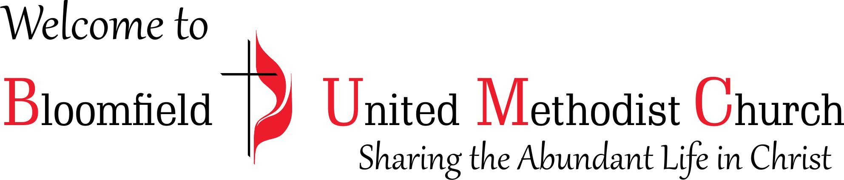

1st Sunday of Advent
December 3, 2023
11:00am

